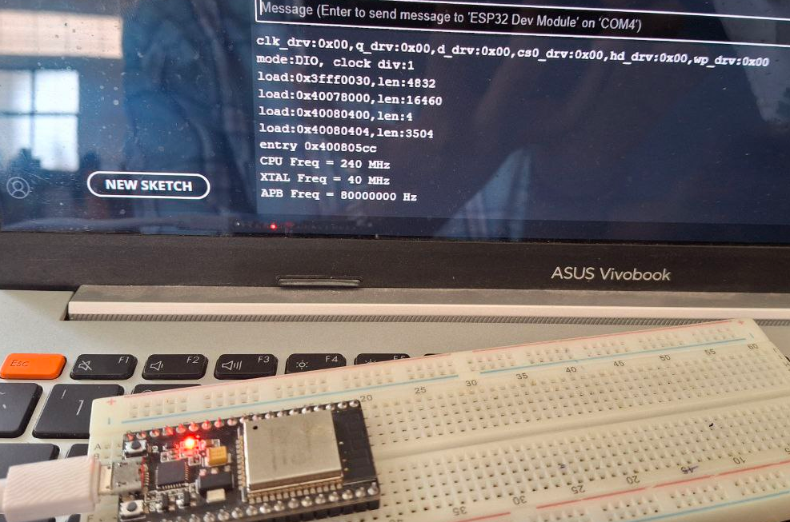

Practical and skill exp 1

Prac2

Skill exp2

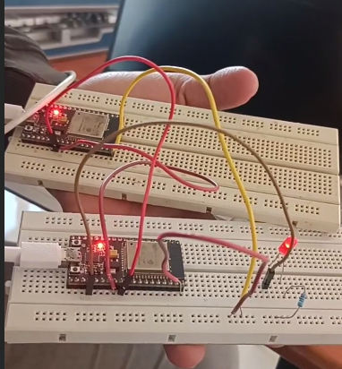  
skill exo 4

skill exp 5

prac exp5

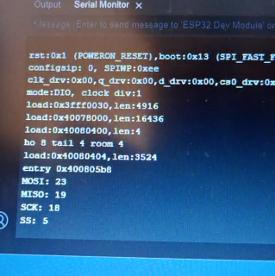  
skill exp 7

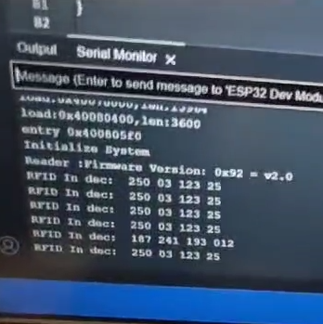  
prac exp 7